

Dr. John, West inc.

2018-11-16

Dr. West

831 Michael Fork, Williamsonside, OK 22948

Phone: 392808752

Fax: 8200954077

**Re:** Michelle, Davis

**PHN:** 659393116

**Birthdate:** 21-Jul-2004

**Address:** 502 Nicole Ville Suite 620, Cummingsberg, CO 72513

**Patient number:** 5983887766

To Whom It May Concern:

This is a medical letter to state the above patient is pregnant with expected delivery date of 29-Apr-2025. Hoping this information is satisfactory for your requirements.

Thank you.

Sincerely,

Dr. John, West

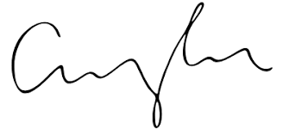

FRCS© NCMP

Clinical Assistant Professor, UBC

Department of Obstetrics and Gynecology SMH